The Nautilus Development Team recently deployed a new web application hosted on an EC2 instance within a public VPC named xfusion-vpc. The application, running on an Nginx server, should be accessible from the internet on port 80. Despite configuring the security group xfusion-sg to allow traffic on port 80 and verifying the EC2 instance settings, the application remains inaccessible from the internet. The team suspects that the issue might be related to the VPC configuration, as all other components appear to be set up correctly. The DevOps team has been asked to troubleshoot and resolve the issue to ensure the application is accessible to external users.
As a member of the Nautilus DevOps Team, your task is to perform the following:
- Verify VPC Configuration: Ensure that the VPC xfusion-vpc is properly configured to allow internet access.
- Ensure Accessibility: Make sure the EC2 instance xfusion-ec2 running the Nginx server is accessible from the internet on port 80.

Use below given AWS Credentials: (You can run the showcreds command on aws-client host to retrieve these credentials)
Console URL | https://423161405967.signin.aws.amazon.com/console?region=us-east-1
Username | kk_labs_user_213172
Password | 0UIGzH65B!n@
Start Time | Tue Jan 13 06:07:05 UTC 2026
End Time | Tue Jan 13 07:07:05 UTC 2026
Notes:
- Create the resources only in us-east-1 region.
- To display or hide the terminal of the AWS client machine, you can use the expand toggle button as shown below:\n

Solutions:-
Verify VPC Internet Connectivity
- Check Internet Gateway (IGW):
  - Go to VPC → Internet Gateways in the AWS console.
  - Ensure an IGW is attached to xfusion-vpc.
  - If missing, create a new IGW and attach it to xfusion-vpc.

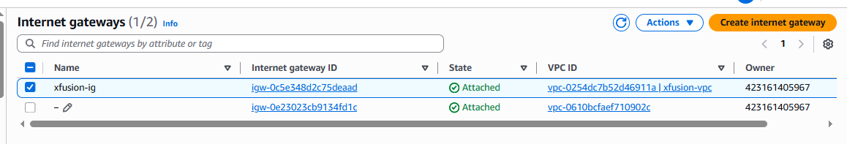

Verify EC2 Instance Accessibility
- Public IP / Elastic IP:
  - Confirm xfusion-ec2 has a public IP or Elastic IP.

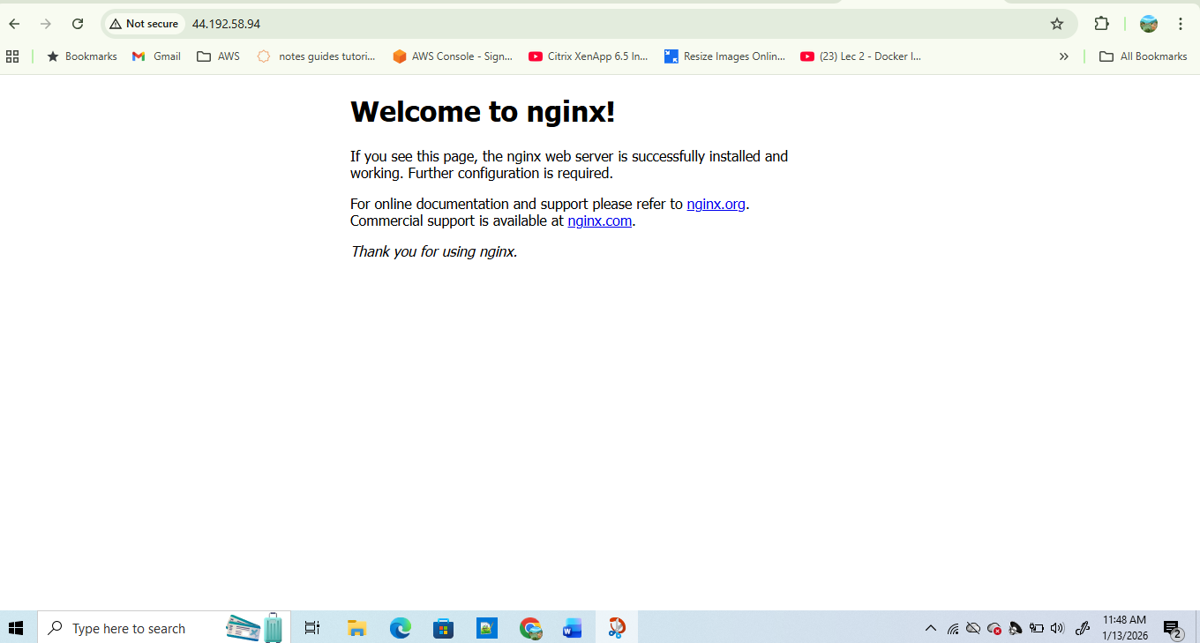

Common Fix Summary
- Attach an Internet Gateway to xfusion-vpc.

